1. Cover Page
Project Title:EnergonX
Course:: Btech CSE with cyber security specialisation
Institution:Lamrin tech skills university Punjab
Instructor:Mr. Rohit Nanda Sir
Semester:4th
Submission Date:13-03-2026
Team Members:-
Name | Roll No | Responsibility
Jai Suhas phadtare | 24100030024 | Authentication APIs
Manpreet singh | 24100030033 | Vulnerability scanner
Nandini jaishree | 24100030037 | API Integration
Neetish Yadav | 24100030038 | Logs and Alert
Tabinda Naseem | 24100030055 | Penetration Testing
Vikram kumar | 24100030060 | Network monitor

2. Declaration
We hereby declare that the project titled “EnergonX Cybersecurity Dashboard” is an original work developed by us as part of our academic curriculum. The project has been carried out under the valuable guidance and supervision of our instructor, whose support and direction greatly contributed to the successful completion of this work.
We further affirm that the contents of this project report have not been submitted earlier to any other institution or university for the purpose of obtaining any academic degree, diploma, or certification. All sources of information, references, and materials used during the preparation of this project have been appropriately cited and acknowledged.
While developing this project, we adhered to standard cybersecurity principles, ethical practices, and responsible implementation methods to ensure that the system was designed and executed in a secure and professional manner.
Names of Students
- Jai suhas phadtare
- Manpreet singh
- Nandini jaishree
- Neetish kumar yadav
- Tabinda naseem
- Vikram kumar
Class / Batch: Crypto/2024 batch
Date: 13-03-2026

3. Acknowledgement
We would like to express our sincere gratitude to our instructor and project guide for their valuable guidance, continuous support, and encouragement throughout the development of the project titled “EnergonX Cybersecurity Dashboard.” Their suggestions and insights played an important role in helping us successfully complete this work.
We are also thankful to our institution and faculty members for providing the necessary resources, facilities, and learning environment that enabled us to carry out this project effectively.
We would like to extend our appreciation to our classmates and friends who supported us with their suggestions and motivation during the development of the project.
Finally, we are deeply grateful to our families for their constant encouragement, patience, and moral support, which helped us stay motivated and complete this project successfully.

4. Abstract
The EnergonX Cybersecurity Dashboard is a security monitoring and vulnerability analysis platform designed to provide centralized visibility into network activities and potential security threats. The primary goal of this project is to assist administrators and security professionals in identifying vulnerabilities, monitoring network traffic, and responding to threats in an efficient and organized manner.
The system integrates several widely used cybersecurity tools such as Nmap, Nikto, Metasploit, Burp Suite, and Wireshark to perform different types of security scans and monitoring operations. By combining the outputs of these tools into a single interactive dashboard, the platform enables users to observe scan results, detect open ports, analyze network traffic, and identify possible attack attempts in real time.
The application follows an API-based backend architecture with a web-based dashboard interface that allows users to perform vulnerability scans by entering target IP addresses or URLs. The backend executes the selected security tools and processes their results, which are then displayed on the dashboard along with alerts, logs, and monitoring data.
In addition, the system includes secure authentication features such as user login and registration to ensure controlled access to the dashboard. The project demonstrates how multiple cybersecurity tools can be integrated into a unified monitoring platform to improve security analysis, vulnerability detection, and overall network awareness.
Overall, the EnergonX Cybersecurity Dashboard provides a practical approach to centralized security monitoring by combining vulnerability scanning, traffic analysis, and alert generation within a single system.

5. Project Objectives
To design and develop the EnergonX Cybersecurity Dashboard for monitoring network security activities.
• To provide real-time visibility of network threats and vulnerabilities through a centralized interface.
• To integrate multiple cybersecurity tools such as Nmap, Nikto, Metasploit, Burp Suite, and Wireshark into a single platform.
• To detect security issues like open ports, suspicious traffic, and injection attempts.
• To implement secure authentication mechanisms using login and registration APIs.
• To generate security alerts and logs for detected vulnerabilities.

6. Technology Stack
Frontend:
React.js, TypeScript, Tailwind CSS, Vite, React Router
Backend:
Python-based API Server, Node.js, Express.js, CORS, Child Process Execution
Database:
MongoDB – Flexible threat intelligence storage
Operating System:
Linux / Kali Linux Environment
Security Tools:
Nmap, Nikto, Metasploit, Burp Suite, Wireshark, ARP-scan , Iftop ,Nethogs,Nuclei, Subfinder & Assetfinder (Recon Tools), HTTPX (The Life Checker), Shodan API, VirusTotal API
Cloud / Hosting:
Local server environment for testing and development

7. Security Tools Used
The EnergonX system integrates several widely used cybersecurity tools for monitoring and vulnerability detection.
- Nmap – Used to scan networks and detect open ports and active services.
- Nikto – Performs web server vulnerability scanning.
- Metasploit – Used to simulate penetration testing scenarios and validate vulnerabilities.
- Burp Suite – Helps test web applications for security weaknesses.
- Wireshark – Monitors and analyzes network traffic packets.
- ARP – Network device discovery
- Iftop – Network traffic monitoring
- Nethogs – Bandwidth usage monitoring

8. System Architecture
The EnergonX Cybersecurity Dashboard follows a modular architecture consisting of the following components:
- User Interface (Dashboard)
Allows users to login, start scans, and view monitoring results.
- Authentication System
Handles user login and registration through API-based authentication.
- Backend API Server
Processes user requests and executes cybersecurity tools.
- Security Tools Engine
Runs scanning tools such as Nmap and Nikto to detect vulnerabilities.
- Data Storage System
Stores user information, scan results, alerts, and logs.
- Visualization Layer
Displays scan results, alerts, and monitoring information in real time.
+-------------------------+
| User / SOC |
+-----------+-------------+
|
v
+---------------------------+
| React Dashboard (UI) |
+-------------+-------------+
|
v
+--------------------------+
| Node.js Express API |
+------------+-------------+
|
+----------+---------+-----------+----------+
| | | |
v v v v
Nmap ARP Iftop Nethogs
Port Scanner Device Discovery Traffic Monitor Bandwidth

9. Cybersecurity Implementation

1. Access Control (Least Privilege)
The system ensures that only authenticated users can access the dashboard. Administrative privileges are restricted to authorized users.

2. Defense in Depth
Multiple layers of protection are implemented including authentication, monitoring tools, and vulnerability scanning.

3. Fail Secure Mechanism
If authentication fails or errors occur, the system denies access and prevents unauthorized operations.

4. HTTPS Implementation
Secure communication protocols are used to protect data exchange between users and the system.

5. Input Validation
User inputs such as target URLs or IP addresses are validated before initiating scans to prevent malicious commands.

6. Authentication and Authorization
Login and registration APIs verify user credentials before granting access to the dashboard.

7. Data Encryption
Sensitive information such as user credentials is stored securely using encryption and hashing techniques.

8. Secure Session Management
User sessions are managed through secure tokens and expire after inactivity to prevent unauthorized access.

10. OWASP Top 10 Security Implementation

Broken Access Control
- Authentication APIs restrict unauthorized access to dashboard features.

Cryptographic Failures
- Sensitive user information is protected using encryption techniques.

Injection Attacks
- Input validation prevents command injection and malicious input execution.

Insecure Design
- The system follows a structured architecture with secure modules.

Security Misconfiguration
Security tools are properly configured to avoid exposure of sensitive data.

Vulnerable Components
Regular scanning ensures outdated or vulnerable services are detected.

Authentication Failures
- Strong login validation prevents unauthorized access attempts.

Software Integrity Failures
- Trusted libraries and verified security tools are used.

Logging and Monitoring Failures
- System logs track scanning activity and security alerts.

Server Side Request Forgery
- User-provided URLs are validated to prevent unauthorized server requests.

11. Security Tool Documentation
The EnergonX Cybersecurity Dashboard integrates several widely used cybersecurity tools that perform network scanning, vulnerability detection, penetration testing, and traffic monitoring. Each tool contributes to a different aspect of the system’s security monitoring capabilities.

11.1 Nmap (Network Mapper)

Purpose
Nmap is an open-source network scanning tool used to discover hosts and services on a computer network. It is widely used by security professionals to identify open ports, running services, and potential vulnerabilities in network systems.

Role :
In the system, Nmap is used to:
- Perform network port scanning
- Identify open ports on target systems
- Detect running services
- Assist in vulnerability identification

Command Used:
nmap -sV target_ip

Command Explanation
Parameter | Meaning
nmap | Network scanning tool
-sV | Service version detection
target_ip | IP address of the system being scanned

Working Principle
- Nmap sends specially crafted packets to the target host.
- The host responds with packet responses.
- Nmap analyzes the responses to determine:
  - open ports
  - service types
  - service versions.

Example Output:
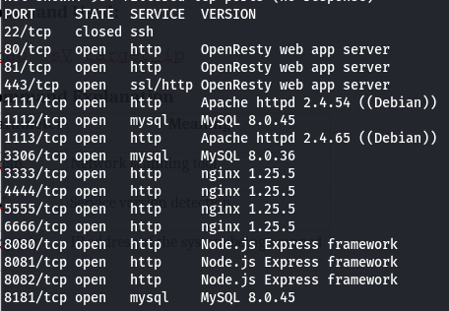

Security Benefit
This information helps administrators identify:
- unnecessary open ports
- outdated services
- possible attack surfaces.

11.2 Nikto Web Vulnerability Scanner

Purpose
Nikto is an open-source web server scanner used to detect:
- server misconfigurations
- outdated software versions
- known vulnerabilities.

Role in EnergonX
Nikto is used to perform web application vulnerability scanning.
It helps identify:
- insecure server configurations
- dangerous files
- outdated server software.

Command Used:
nikto -h target_url

Command Explanation
Parameter | Meaning
nikto | Web vulnerability scanner
-h | Specifies the host or URL
target_url | Website to be scanned

Working Principle
Nikto sends HTTP requests to the web server and compares the responses with a database of known vulnerabilities.

Example Output:
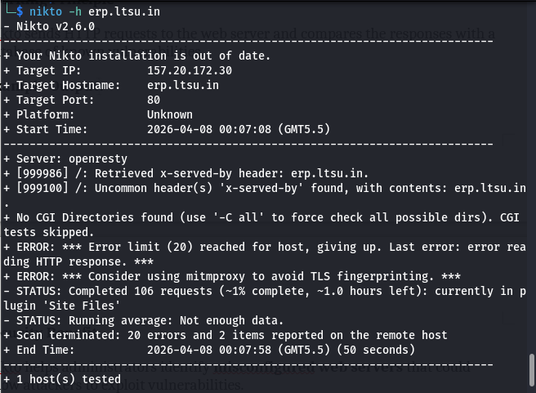

Security Benefit
Nikto helps administrators identify misconfigured web servers that could allow attackers to exploit vulnerabilities.

11.3 Metasploit Framework

Purpose
Metasploit is a penetration testing framework used for developing and executing exploit code against vulnerable systems.

Role in EnergonX
In EnergonX, Metasploit is used to:
- simulate penetration testing scenarios
- validate discovered vulnerabilities
- demonstrate exploit possibilities.

Example Command:
msfconsole
Example exploitation module:
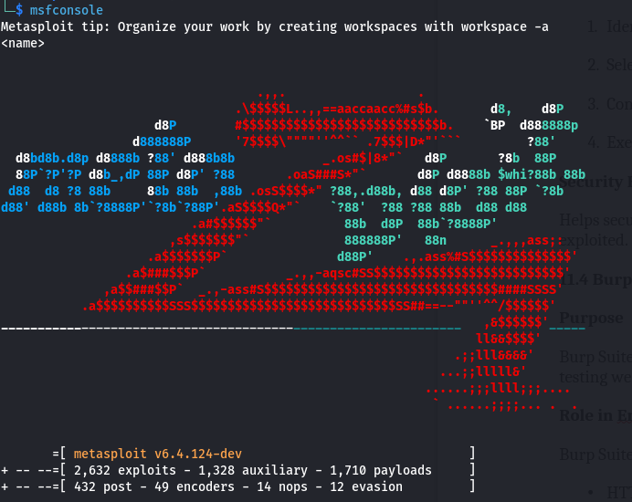

Working Principle
- Identify vulnerability.
- Select exploit module.
- Configure target parameters.
- Execute exploit against target.

Security Benefit
Helps security professionals test whether vulnerabilities can actually be exploited.

11.4 Burp Suite

Purpose
Burp Suite is a web application security testing platform used for analyzing and testing web applications for vulnerabilities.

Role in EnergonX
Burp Suite helps analyze:
- HTTP requests and responses
- authentication mechanisms
- web application vulnerabilities.
BrupSuite Look
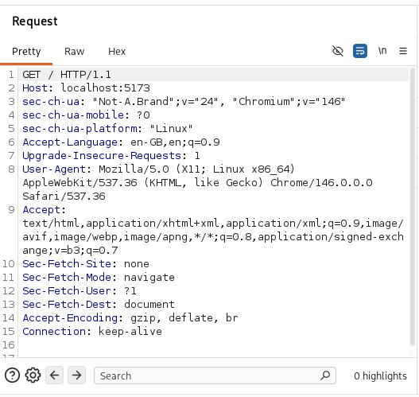

Key Components
Component | Function
Proxy | Intercepts web traffic
Scanner | Detects vulnerabilities
Intruder | Performs automated attacks
Repeater | Modifies requests manually

Example Vulnerabilities Detected
- SQL Injection
- Cross-Site Scripting (XSS)
- Broken Authentication
- Session Hijacking

Security Benefit
Burp Suite allows testers to identify and analyze security weaknesses in web applications.

11.5 Wireshark

Purpose
Wireshark is a network protocol analyzer used to capture and analyze network packets.

Role in EnergonX
Wireshark helps administrators monitor:
- network traffic
- packet communication
- suspicious activities.

Working Principle
Wireshark captures packets from network interfaces and displays them in a detailed format.

Example Packet Data:
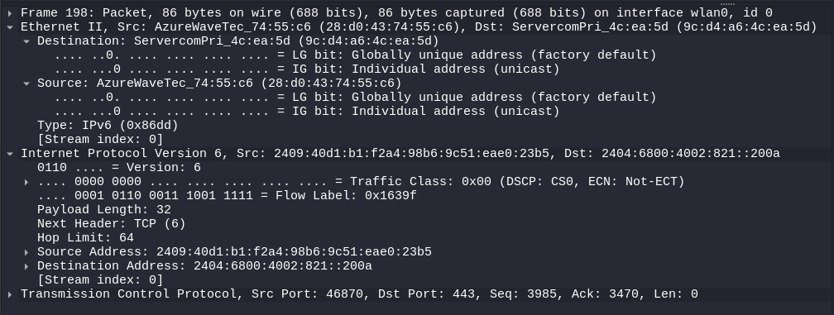

Security Benefit:
It helps detect:
- abnormal traffic patterns
- malware communication
- suspicious network behavior.

11.6 Nethogs (Network Bandwidth Monitor)

Purpose
Nethogs monitors network bandwidth usage by processes.

Role in EnergonX
It allows administrators to detect:
- which application is consuming bandwidth
- suspicious network activity.

Command Used:

sudo nethogs

Example Output

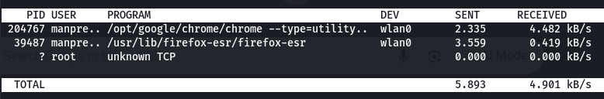
Security Benefit
Helps identify malware or unauthorized applications consuming network resources.

11.7Assetfinder / Subfinder
Eh tools recon (information gathering) layi use hunde ne.
- Role: Subdomain Discovery.
- How it works: Ek main domain (jive bing.com) de saare hidden subdomains (jive api.bing.com) labhda hai.
- Why in Scanner: Kyuki hacker aksar main site di jagah hidden subdomains te attack karde ne.

11.8 Nuclei (The Main Engine)
Eh tuhade scanner da sab ton zaroori tool hai.
- Role: Template-based scanning.
- How it works: Isde kol hazaran security "templates" hunde ne. Eh website te send karke check karda hai ki koi purani vulnerability (CVE) ya misconfiguration taan nahi hai.
- Best for: Finding SQL Injection, XSS, te Cloud misconfigurations.

11.9 Shodan (The Search Engine for Internet-Connected Devices)
- Role: It is used to find "Internet Metadata" without even touching the target.
- How it works: Shodan scans the entire internet 24/7. EnergonX uses the Shodan API to pull this data instantly.
- In EnergonX: * It identifies the Operating System (e.g., Linux 5.x or Windows Server).
  - It lists Open Ports and Services (e.g., Port 22 for SSH, Port 3306 for MySQL).
  - It tells us the Organization (e.g., Google, Amazon, or Microsoft) that owns the IP.
- Why use it? It’s "Passive Recon." We get information without sending a single packet to the target, making us invisible to their firewalls.

11.10 VirusTotal (The Reputation Engine)
- Role: It is used to check if a target IP or Domain is "Clean" or "Malicious."
- How it works: It aggregates data from over 70+ Antivirus scanners and URL/domain blacklisting services.
- In EnergonX: * It shows a Malicious Hit Count (e.g., "4/70 scanners flagged this IP").
  - It provides a Reputation Score.
  - If a target has a high malicious count, the EnergonX dashboard triggers a Critical Alert.
- Why use it? It helps us identify if we are communicating with a known "Command & Control" (C2) server or a malware-hosting site.

12. Screenshot Documentation
The project documentation includes screenshots showing:
- Tool setup and execution
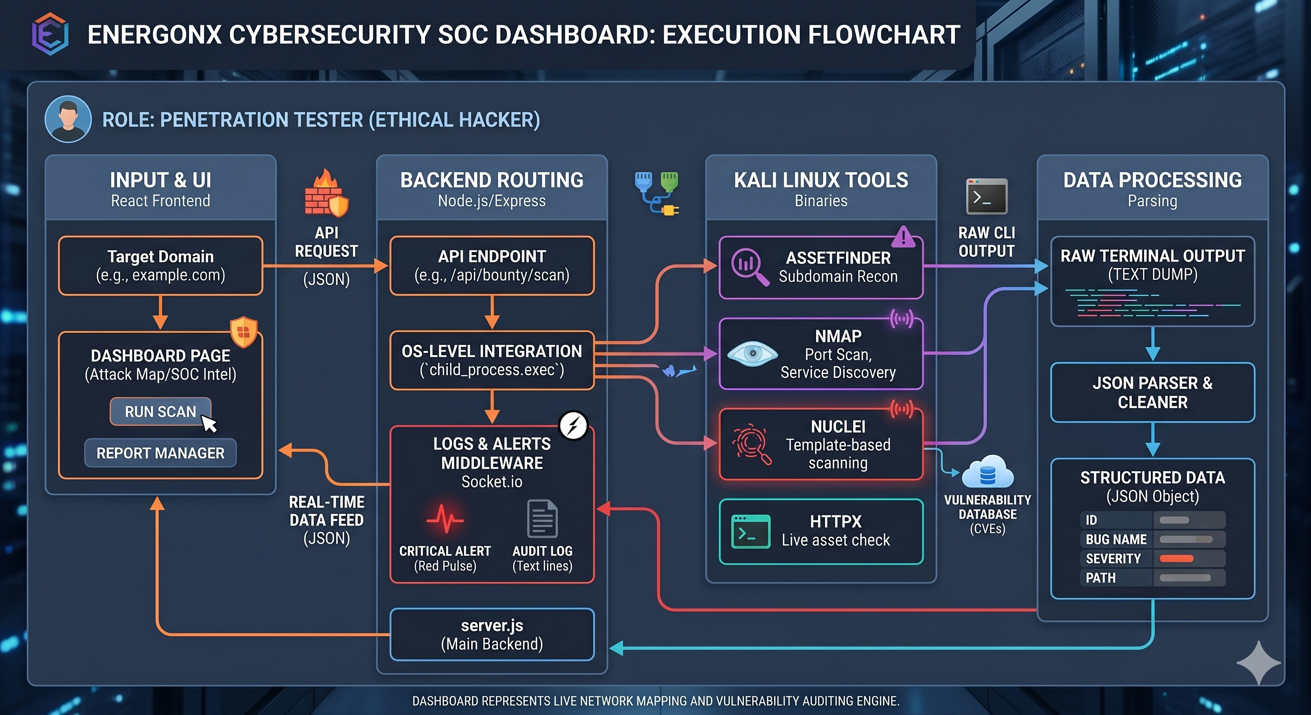
A vertical Navigation Sidebar for the "EnergonX" application, featuring menu items such as Dashboard, Vulnerability Scanner, Network Monitor, and Penetration Testing.
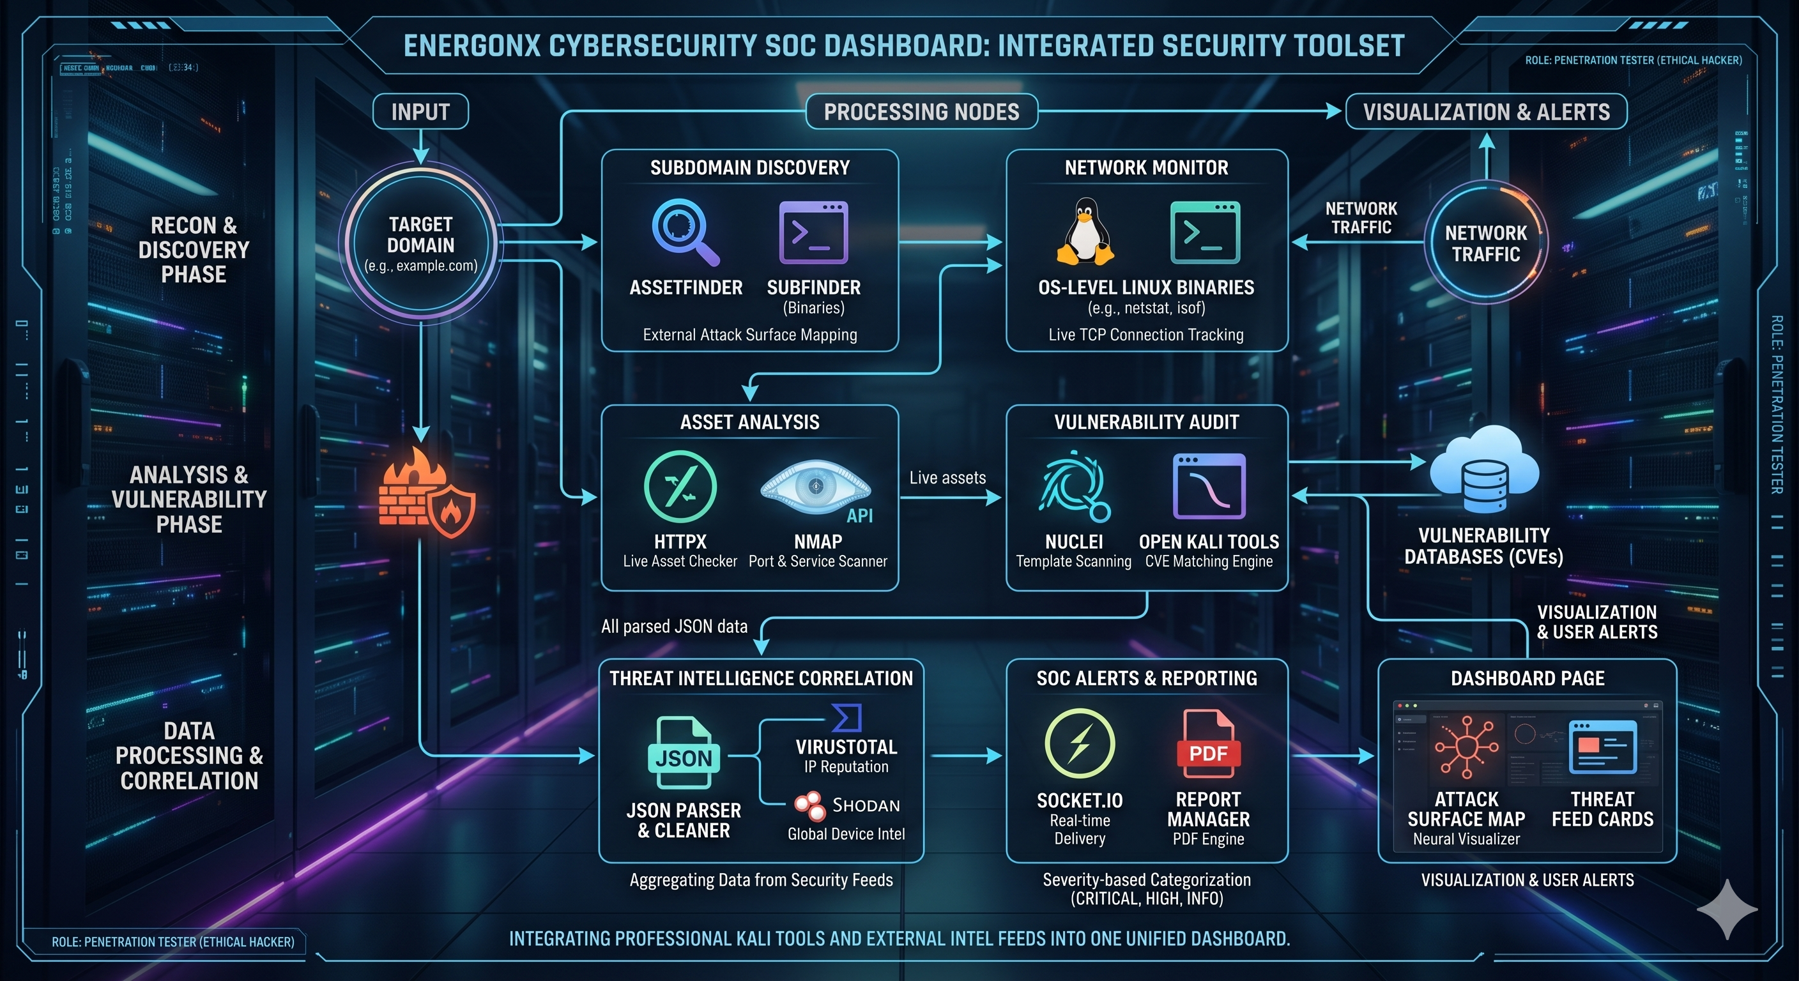

- Scan commands and inputs
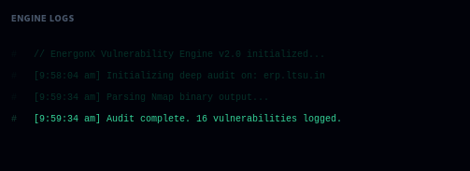
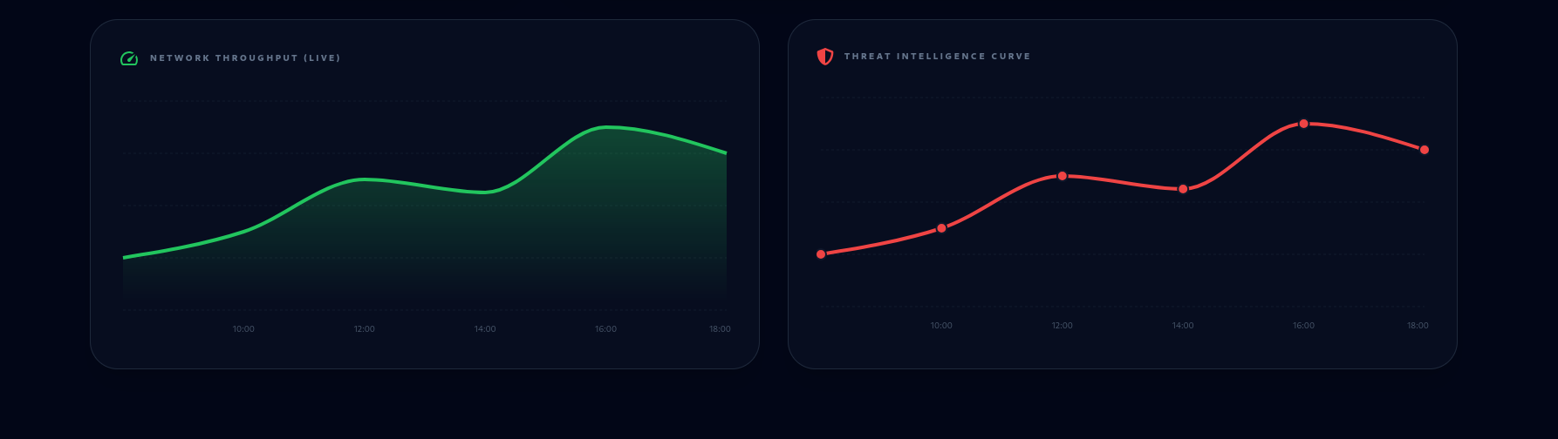
A detailed Nmap Scan Result output in a terminal, confirming the scan was completed on the target IP and found ports 80 and 443 to be open.
This image illustrates the network traffic analysis graph within the dashboard. It visualizes traffic patterns over time, helping administrators monitor network activity and detect unusual spikes that may indicate potential security threats or suspicious behavior.
- Scan results and vulnerability outputs
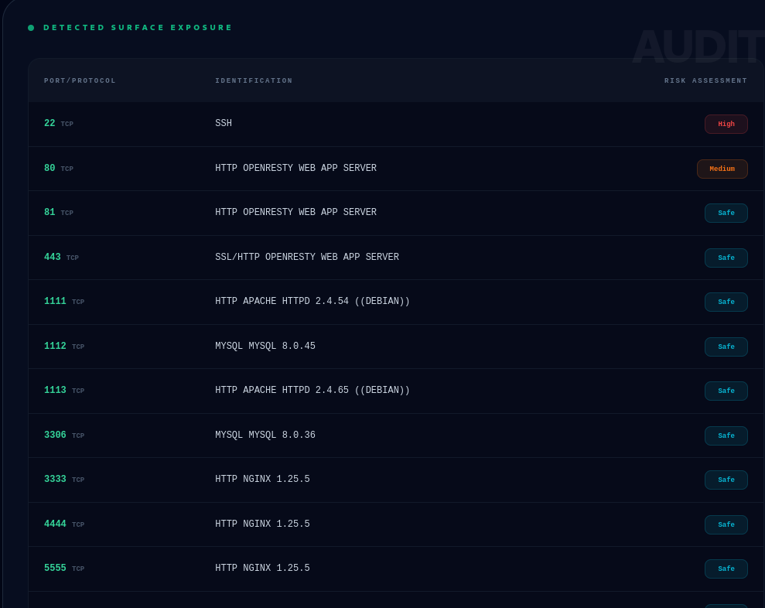
A Live Scan Terminal display showing an Nmap scan in progress against ltsu.ac.in, identifying open HTTP and HTTPS ports.
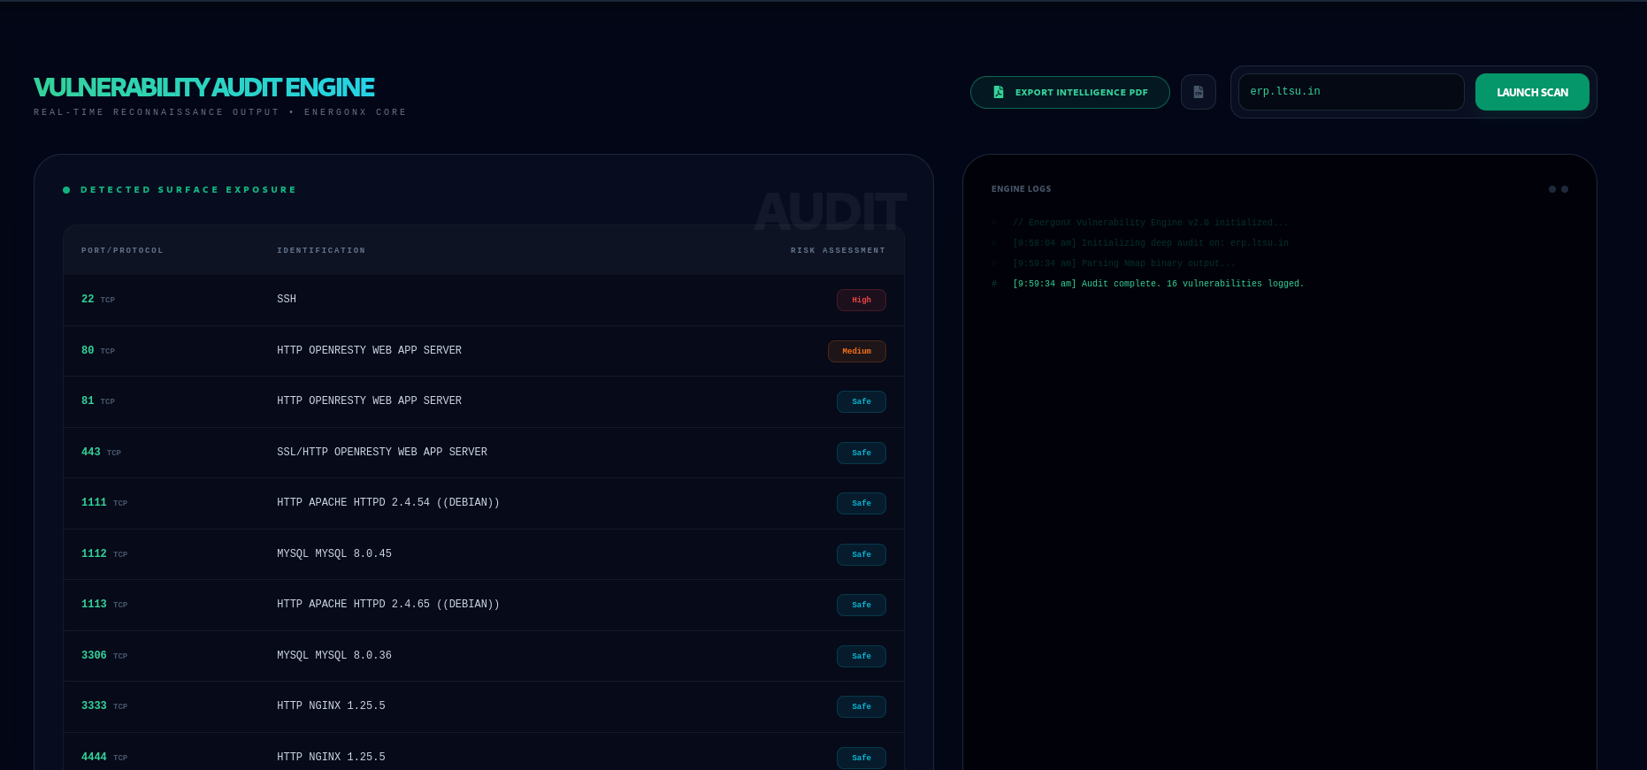
A web interface for a Vulnerability Scanner showing a target input field for ltsu.ac.in and quick-access buttons for tools like Nmap, Nikto, and Metasploit.

- Dashboard interface displaying security alerts
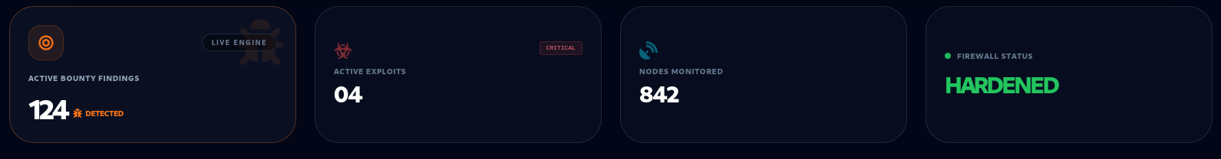
A Security Alerts dashboard displaying three color-coded notifications: a critical SQL Injection attempt, an open port vulnerability, and a successful admin login from a new IP.

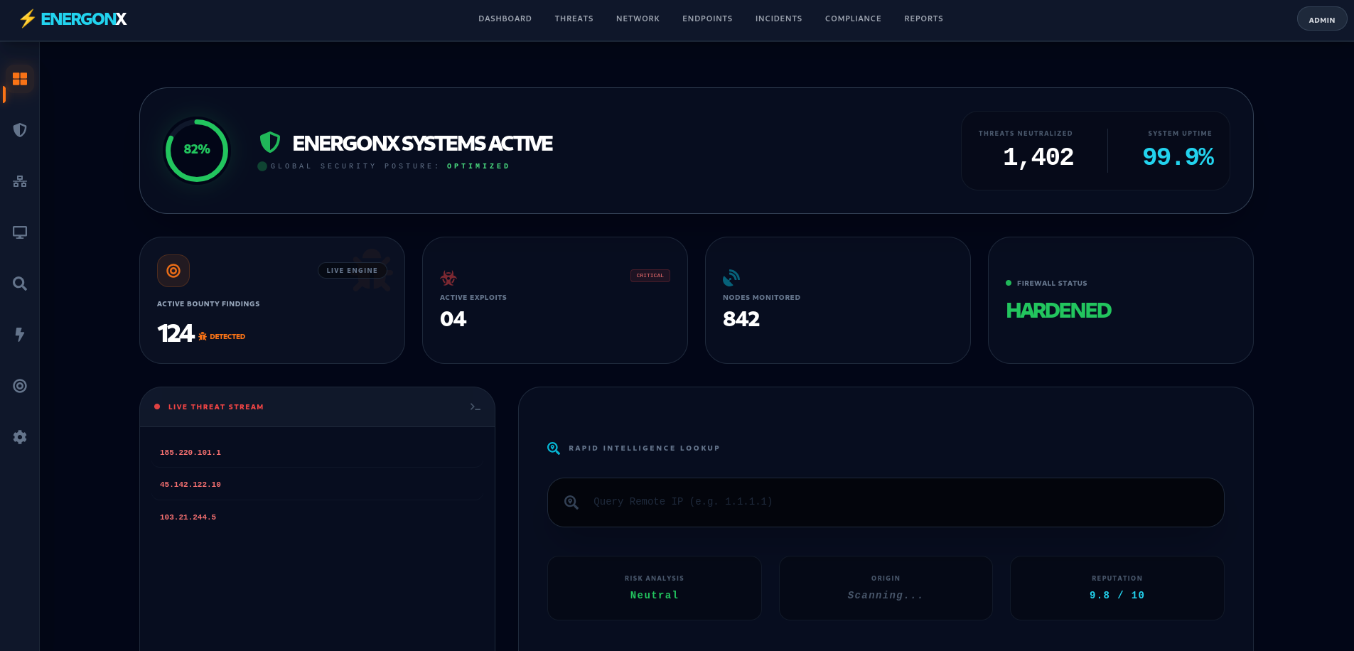
This image shows the main dashboard summary section of the cybersecurity system. It displays key security metrics including the number of Active Scans, Vulnerabilities detected, and Network Alerts. These indicators provide a quick overview of the current security status of the monitored system.

These screenshots demonstrate the functionality of the EnergonX system.

13. Penetration Testing Documentation

Test Name
Network Port Scan
Purpose
To identify open ports and services running on the target system.
Tool Used
Nmap
Input Command
nmap target_ip
INPUT SCREENSHOT
OUTPUT SCREENSHOT
Explanation
The scan reveals open ports that may expose the system to potential attacks. This helps administrators identify weak points in network security.

15. Weekly Progress Report

Week | Activities Performed | Instructor Remarks
Week 1 | Selected project topic and conducted research
Week 2 | Designed system architecture and workflow
Week 3 | Developed backend APIs and authentication system
Week 4 | Integrated cybersecurity tools
Week 5 | Conducted testing and vulnerability scanning
Week 6 | Finalized documentation and prepared report

16. Cybersecurity Implementation Checklist

Security Feature | Implemented
HTTPS Enabled | Yes
Role Based Access Control | Yes
Password Hashing | Yes
SQL Injection Protection | Yes
XSS Protection | Yes
Secure Session Handling | Yes
Input Validation | Yes
Firewall Protection | Yes
Logging & Monitoring | Yes

17. Results and Outputs
.The EnergonX Cybersecurity Dashboard successfully performs network scanning and vulnerability detection. The integrated tools generate scan results which are displayed on the dashboard interface. Administrators can monitor open ports, network traffic, and security alerts in real time.
Screenshots of scan outputs and dashboard views demonstrate the working of the system.

18. Future Improvements
• Integration of AI-based threat detection systems
• Implementation of multi-factor authentication
• Deployment on cloud-based infrastructure
• Addition of automated intrusion detection systems
• Advanced real-time attack monitoring features
• Live cyber attack map visualization
• AI-based anomaly detection
• Integration with Suricata or Zeek IDS
• Automated vulnerability alerts
• Machine learning-based risk scoring

19. References
OWASP Official Website – https://owasp.org
Nmap Official Documentation – https://nmap.org/docs.html
Nikto Web Server Scanner Documentation – https://cirt.net/nikto
Wireshark Network Protocol Analyzer – https://www.wireshark.org/docs
Metasploit Framework Documentation – https://docs.metasploit.com
Burp Suite Web Security Testing Tool – https://portswigger.net/burp
Kali Linux Official Documentation – https://www.kali.org/docs

20. Appendix
The appendix contains supporting materials related to the project including:
• Sample scan outputs
• Command execution screenshots
• System flowcharts and diagrams
• Configuration files and code snippets

Technology & Security Tools Table

Category | Tools / Technologies Used
Programming | Python, HTML, CSS, JavaScript
Database | SQLite / MySQL
Security Testing | Metasploit Framework, Burp Suite
Network Analysis | Wireshark
Vulnerability Scanner | Nmap, Nikto
Cloud Platform | Localhost / Virtual Machine Environment

Teacher Evaluation Sheet
Evaluation Criteria | Marks
Project Idea
Architecture Design
Tool Usage
Team Contribution
Documentation Quality
Penetration Testing
Final Presentation

